Electronic Supplementary Material 1: Selection method of individuals-years included in analysis
For each individual monitored for more than a month, we randomly selected a number of locations in increments of ten, ranging from ten to the tenth below the total number of locations. For each group of ten locations, we repeated the selection process thirty times. We modelled the Minimum Convex Polygon 100% (Mohr, 1947) home range for each selection and measured its size. The average size of the home range was then calculated for the thirty iterations within each group of ten. We plotted the average home range size as a function of the number of selected locations. We visually assessed whether the plot approached an asymptote and identified individuals for which this was the case. This resulted in the selection of 12 individual-years (Figure S7). For these 12 individual-years, we plotted the logarithm of home range size against the logarithm of the number of locations. We calculated the equation of the resulting plot and determined the number of locations needed to model a home range that covered 90% of its total size. Finally, we calculated the average number of locations required across the 12 individual-years and selected all other individual-years with a total number of locations exceeding this mean. It resulted in the selection of four more individual-year for a total of 16 individual-years used for the data analysis (14 different individuals, including two for which two periods over two years of monitoring are available).
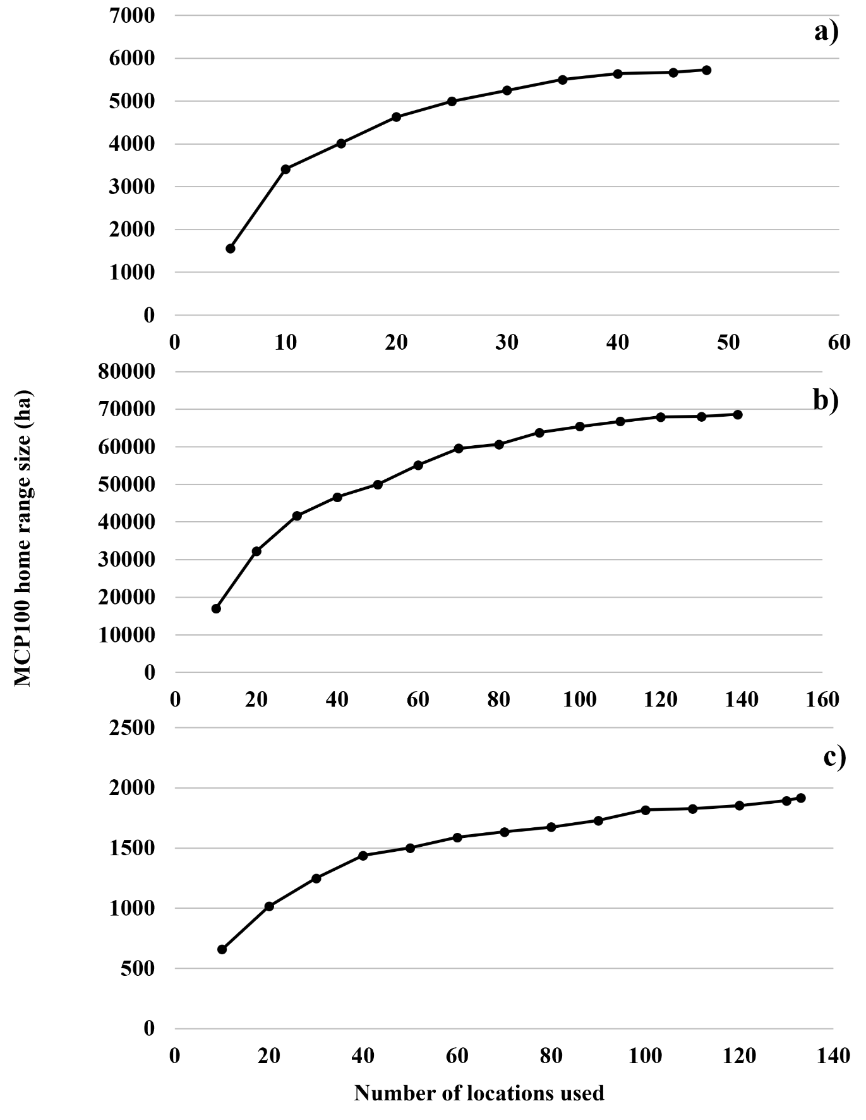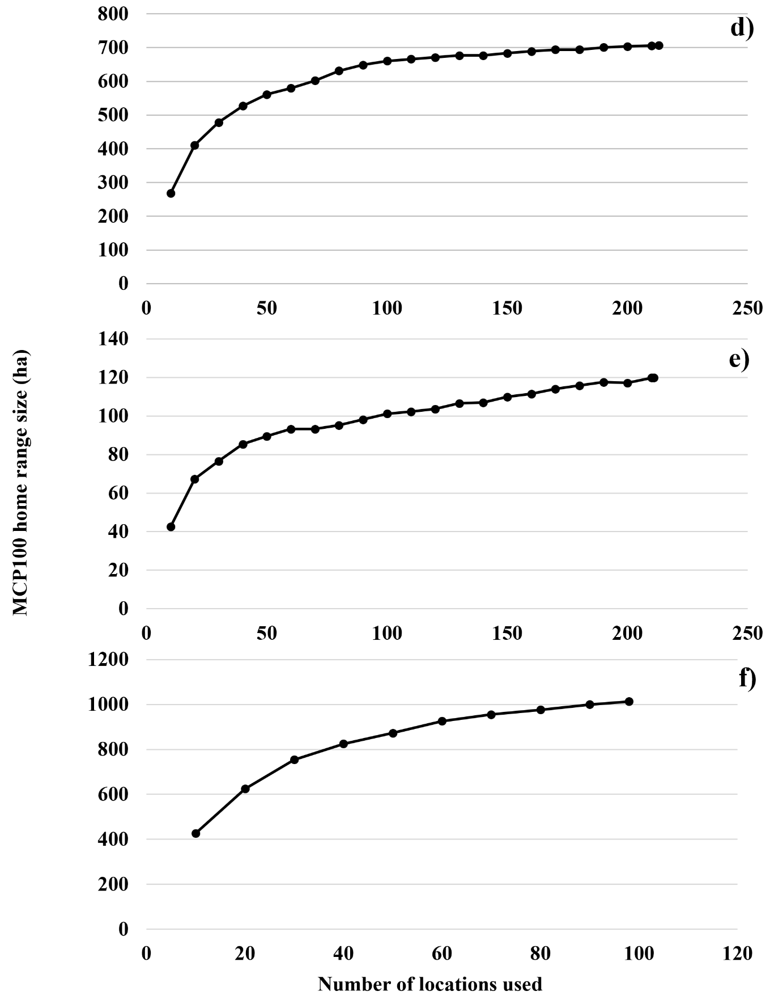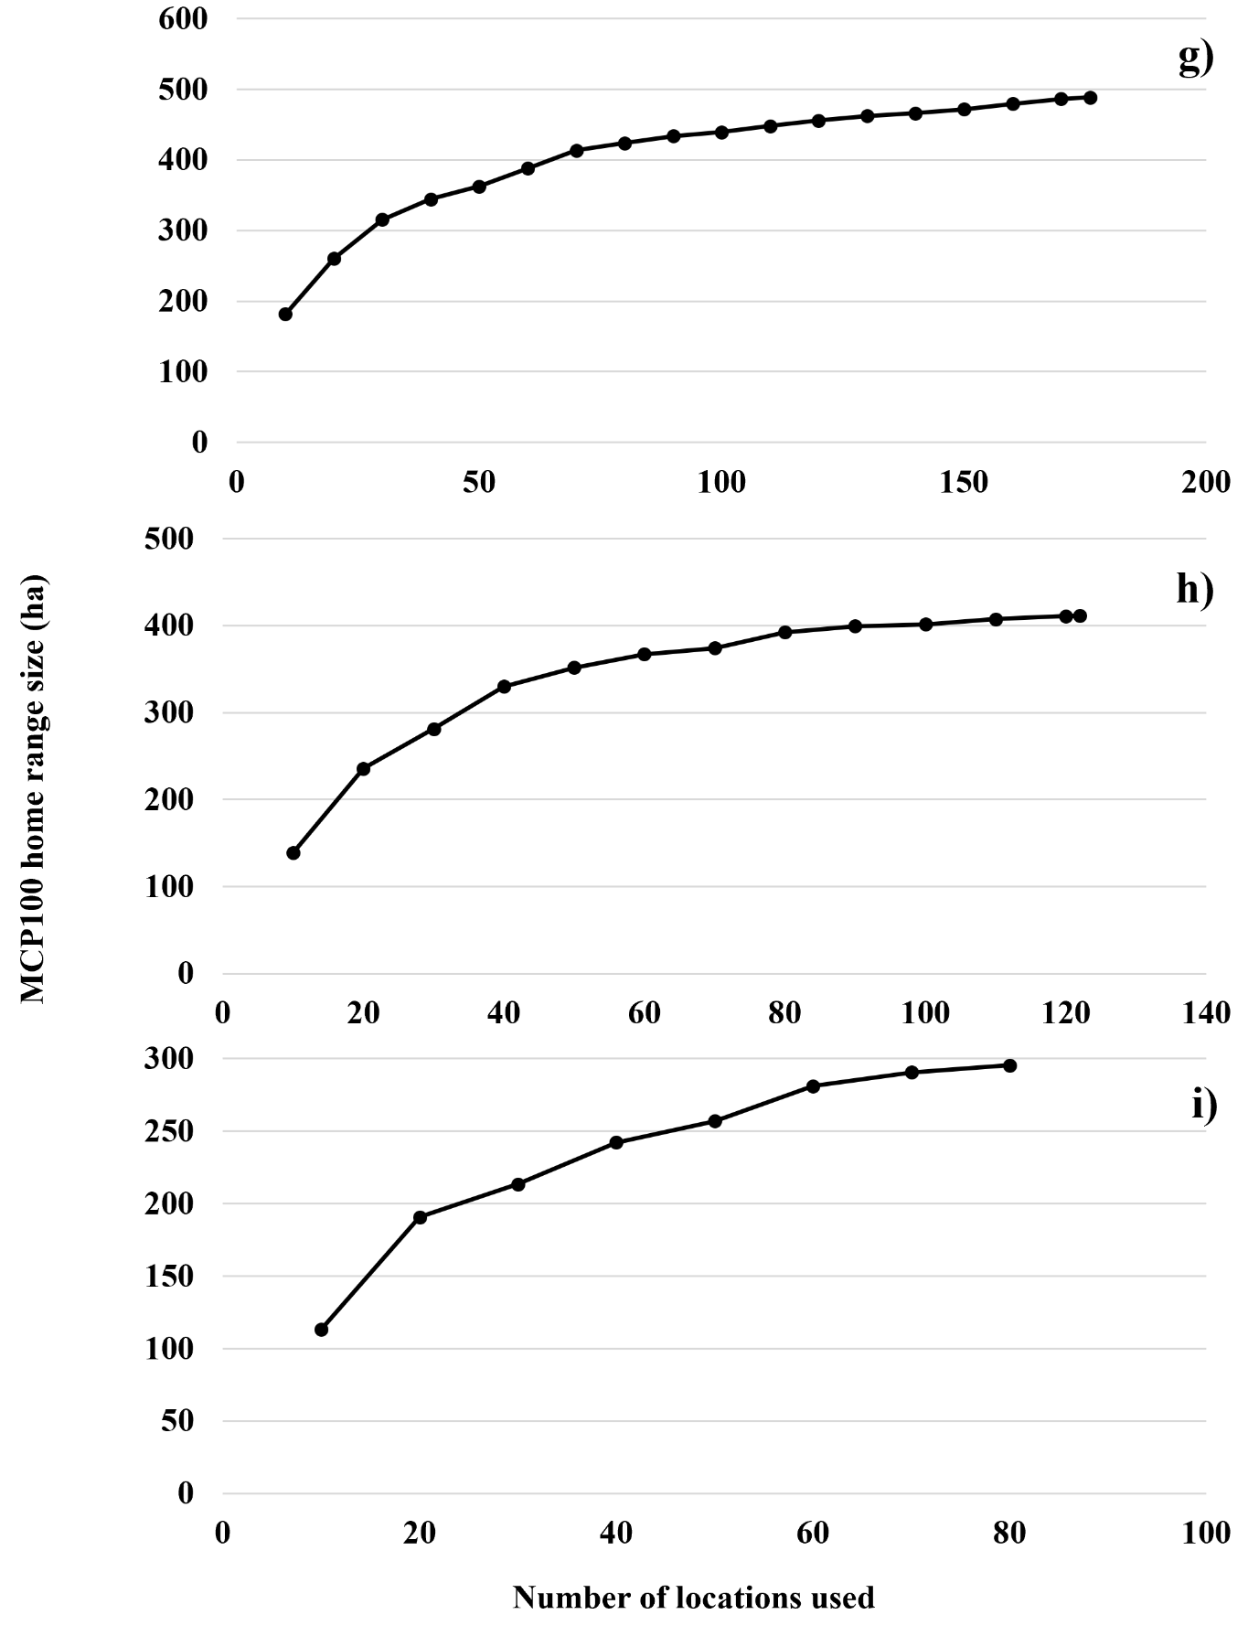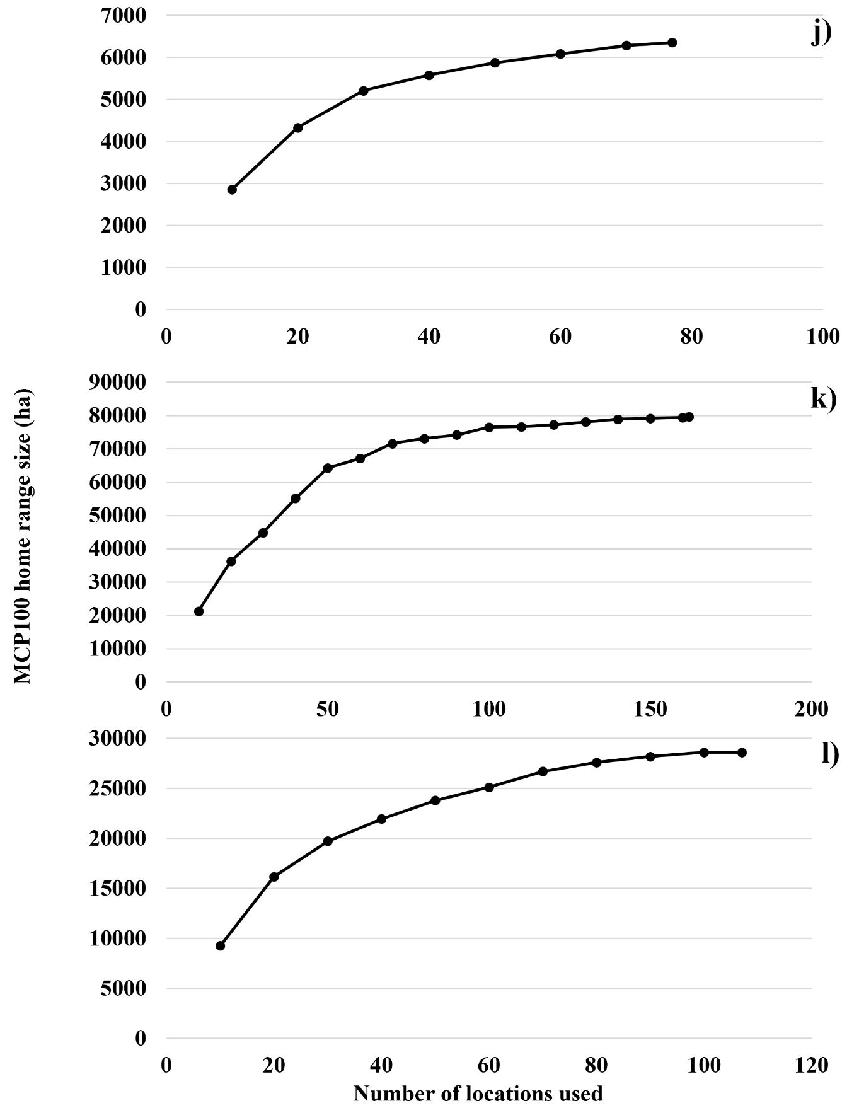
Figure S6 - Plots of the average home range size as a function of the number of selected locations for each individual-year that approached visually an asymptote. a) Badu2, b) Gwenn, c) Hagrid, d) Maya, e) Mellea, f) Popeye, g) Tim, h) M2C, i) M2C2, j) M3E, k) M5C, l) M10C.

Electronic Supplementary Material 2: AIC tables for all models used in this article.
Table S4 - Model structure, Akaike’s Information Criterion adjusted for sample size (${AIC}_{C}$), differences in ${AIC}_{C}$ (${ΔAIC}_{C}$), and Akaike weight ($w_{i}$) for the four models predicting the HR0W (in bold, the selected model).
Variables contained in the model | $${AIC}_{C}$$ | $${ΔAIC}_{C}$$ | $$w_{i}$$
Landscape type + Estimation method | -110.3 | 0.00 | 0.902
Landscape type + Estimation method + Landscape type:Estimation method | -105.6 | 4.62 | 0.090
Estimation method | -100.3 | 9.91 | 0.006
Landscape type | -97.7 | 12.57 | 0.002
Null model | -87.7 | 22.58 | 0.000

Table S5 - Model structure, Akaike’s Information Criterion adjusted for sample size (${AIC}_{C}$), differences in ${AIC}_{C}$ (${ΔAIC}_{C}$), and Akaike weight ($w_{i}$) for the twelve models predicting the home range size using the GAM method (in bold, the models supported by the selection).
Variables contained in the model | $${AIC}_{C}$$ | $${ΔAIC}_{C}$$ | $$w_{i}$$
Landscape type + Sex | 289. | 0.00 | 0.258
Sex | 290.1 | 0.44 | 0.207
Null model | 291.0 | 1.32 | 0.133
Period + Sex | 291.7 | 2.07 | 0.092
Period | 291.9 | 2.20 | 0.086
Landscape type + Period + Sex | 292.3 | 2.62 | 0.070
Landscape type + Sex + Landscape type:Sex | 292.3 | 2.68 | 0.068
Landscape type | 293.1 | 3.38 | 0.048
Landscape type + Period | 294.7 | 4.99 | 0.021
Landscape type + Period + Sex + Landscape type:Sex | 296.3 | 6.62 | 0.009
Period + Sex + Period:Sex | 297.1 | 7.40 | 0.006
Landscape type + Period + Sex + Period:Sex | 298.9 | 9.24 | 0.003
Landscape type + Period + Sex + Landscape type:sex + Period:Sex | 304.9 | 15.19 | 0.000

Table S6 - Model structure, Akaike’s Information Criterion adjusted for sample size (${AIC}_{C}$), differences in ${AIC}_{C}$ (${ΔAIC}_{C}$), and Akaike weight ($w_{i}$) for the twelve models predicting the core area size using the GAM method (in bold, the models supported by the selection).
Variables contained in the model | $${AIC}_{C}$$ | $${ΔAIC}_{C}$$ | $$w_{i}$$
Null model | 244.3 | 0.00 | 0.269
Sex | 244.7 | 0.35 | 0.227
Period | 244.8 | 0.50 | 0.210
Period + Sex | 246.8 | 2.51 | 0.077
Landscape type | 247.0 | 2.67 | 0.071
Landscape type + Sex | 247.1 | 2.73 | 0.069
Landscape type + Period | 248.1 | 3.82 | 0.040
Landscape type + Period + Sex | 250.2 | 5.92 | 0.014
Period + Sex + Period:Sex | 250.7 | 6.40 | 0.011
Landscape type + Sex + Landscape type:Sex | 250.9 | 6.59 | 0.010
Landscape type + Period + Sex + Landscape type:Sex | 255.0 | 10.71 | 0.001
Landscape type + Period + Sex + Period:Sex | 255.1 | 10.74 | 0.001
Landscape type + Period + Sex + Landscape type:sex + Period:Sex | 261.3 | 17.00 | 0.000

